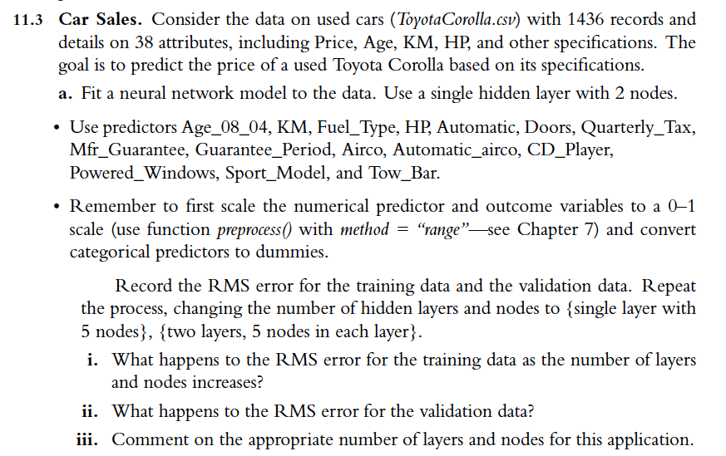

11.3 i)

The first model is the best, it is the one that best fits the RMSE for both the training set and the validation set. As we increase the number of layers and nodes the model tends to overfit the data, i.e., it fits the training set so well that it predicts the validation set data less accurately.

11.3 ii)

Initially, when we used a model with a single layer and two nodes the RMS in the validation set was 0.0405, later in the second model, in which we used a single layer but 5 nodes the RMS increased significantly to 0.042 and in the third model, in which 2 layers and 5 nodes were included the RMS decreased the error with respect to the second model but it was still higher than the first one.

11.3 iii)

As we said before in the first section, the best model and the one that fits best both the training and the validation set is the one with 1 layer and 2 nodes.